**Assignment – 2**

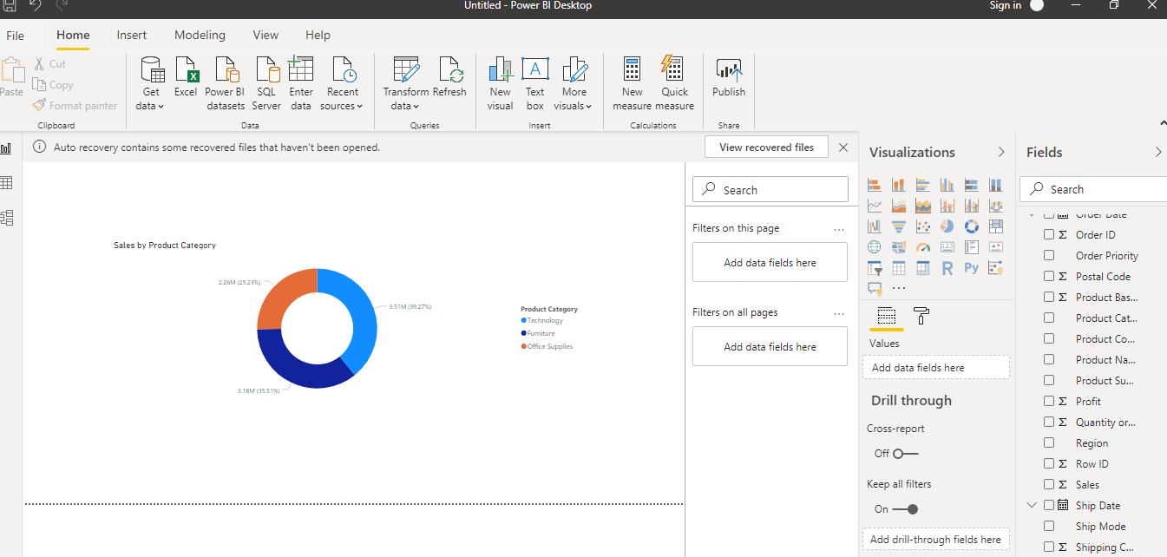**Create a Donut Chart showing sales in terms of Product category**

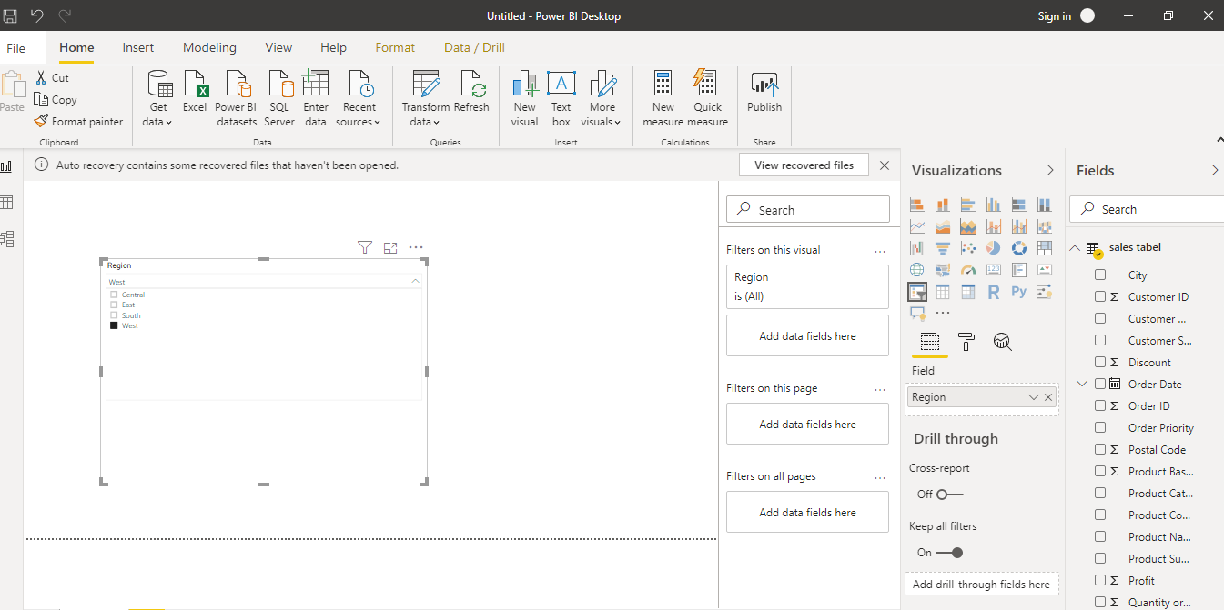**• Create a Slicer and show the regions in dropdown. See how all the visuals mentioned above behaving when a particular region is selected.**

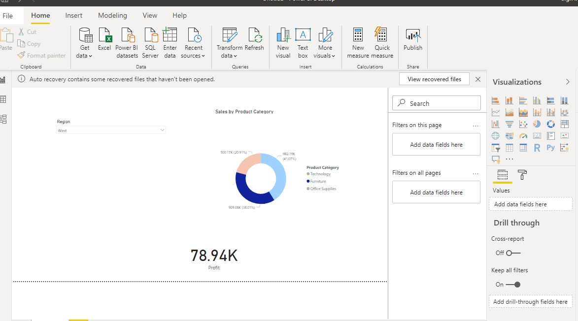

**Create a line and Clustered Column Chart showing the Sales and Discount as per the State or Province**

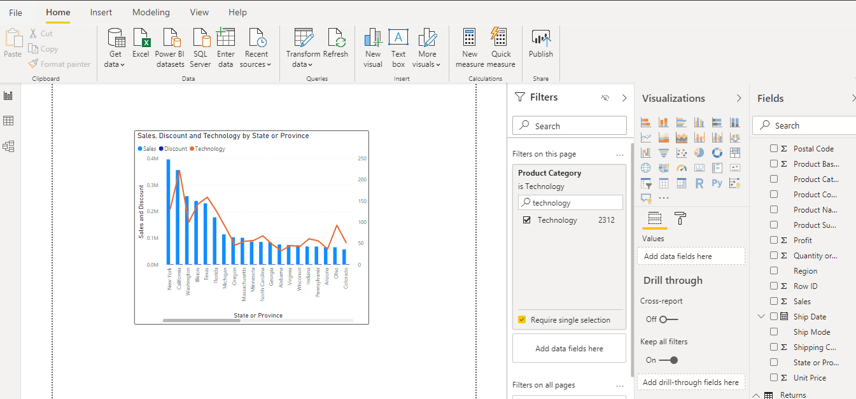**− Format the bars and line with different colors − Which state has the highest sales in terms Technology.**

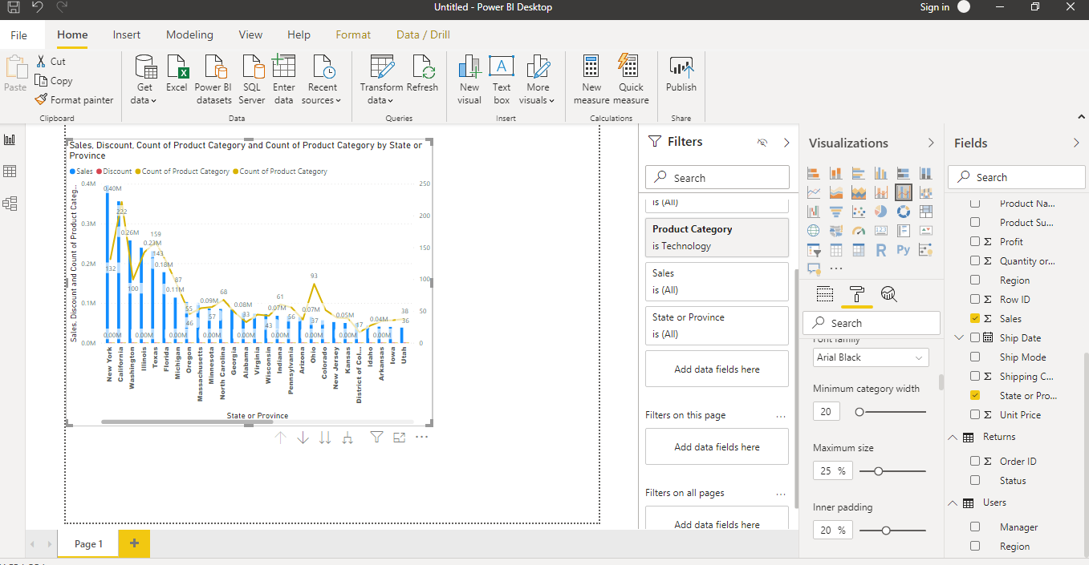

**Connect to the Store Sales Data and do the following: -**

**− Remove all the blank rows. − Update the column header if they are not updated − Create a text table and show the sales in terms of o Customers o Product Category o Regions**

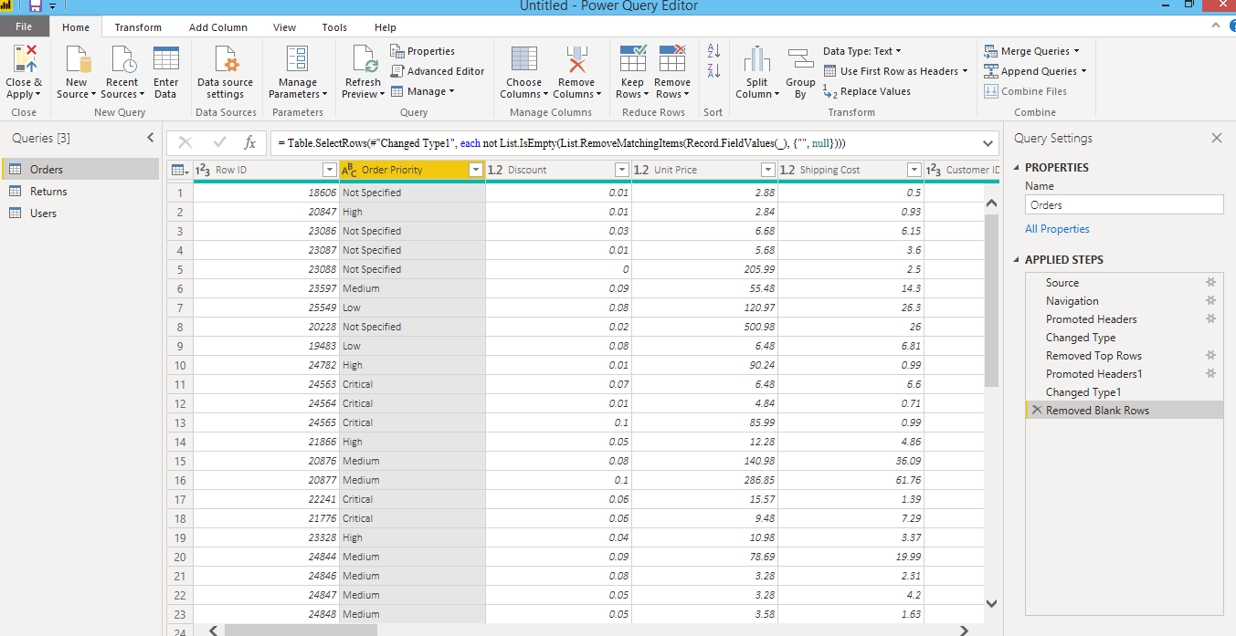**Remove all the blank rows. –**

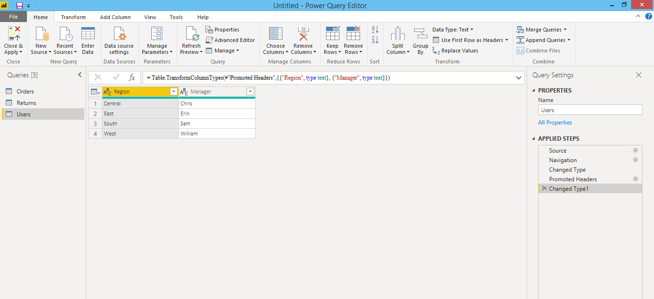**Update the column header if they are not updated**

**Create a text table and show the sales in terms of**

**o Customers**

**o Product Category**

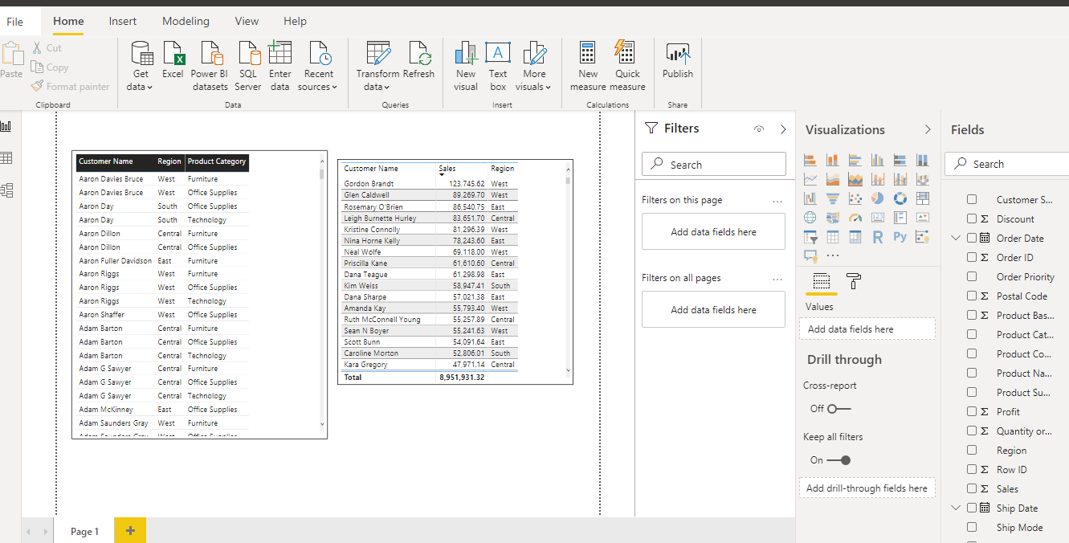**o Regions**